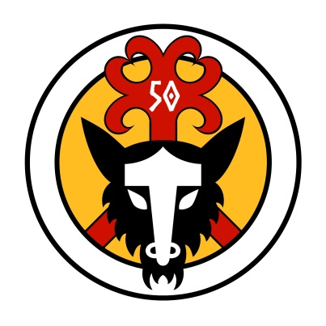 **The Ruby Horde – Forty Years or More**

Today the society membership stands at over 1600 people, representing a spread from newborns to those of over 80. Of those who founded the society back in 1971, all have left the society over the years as finances, interest, politics, age, health and other factors have all taken their toll. Remarkably, one of the founder members, Peter Seymour, rejoined the society in 2015 after a gap of 40 years. While the group he helped to create all those years ago is markedly different from the one we see today, it is on those foundations that we have gone on to build something which has stood the test of time.

Along the way, a large number of people have passed through the portals of the society. The current membership database was established in 2000, before which there was a card index featuring a card per member, and members who did not renew were removed from the index and their card destroyed. Based on the membership records from 2000 onwards, more than 6000 people have joined the society, and so it is likely that we have had somewhere around 8000 individual members over the years, and of course many of those have fallen by the wayside for whatever reason. To those who are no longer with us, we thank you for the time you gave, and the effort you contributed. In keeping with the words of the Havamal:

***Cattle die, kinsmen die; the self must also die. I know one thing which never dies; the reputation of each of the dead***

We remember also those whose long service is now rewarded by a place by the Konungr’s side at the fire, in a seat of honour in recognition of services given. While there are none who have served throughout the 50 years of our existence, these glorious few are recorded to have been members for more than 40 years:

* Allan ‘Blue’ Beneke – 1975
* Terry Warren – 1975
* Jim Gillbanks – 1976
* Bob Clegg – 1978
* Carrie Walker – 1978
* Sandie Gillbanks – 1979
* Ted Lunn – 1979
* Kathy Barry – 1979
* Joyce Mains - 1979
* John Wentzel – 1980
* Stuart Howe – 1981

As the Anglo-Saxons have taught us well...

Waes Hael!