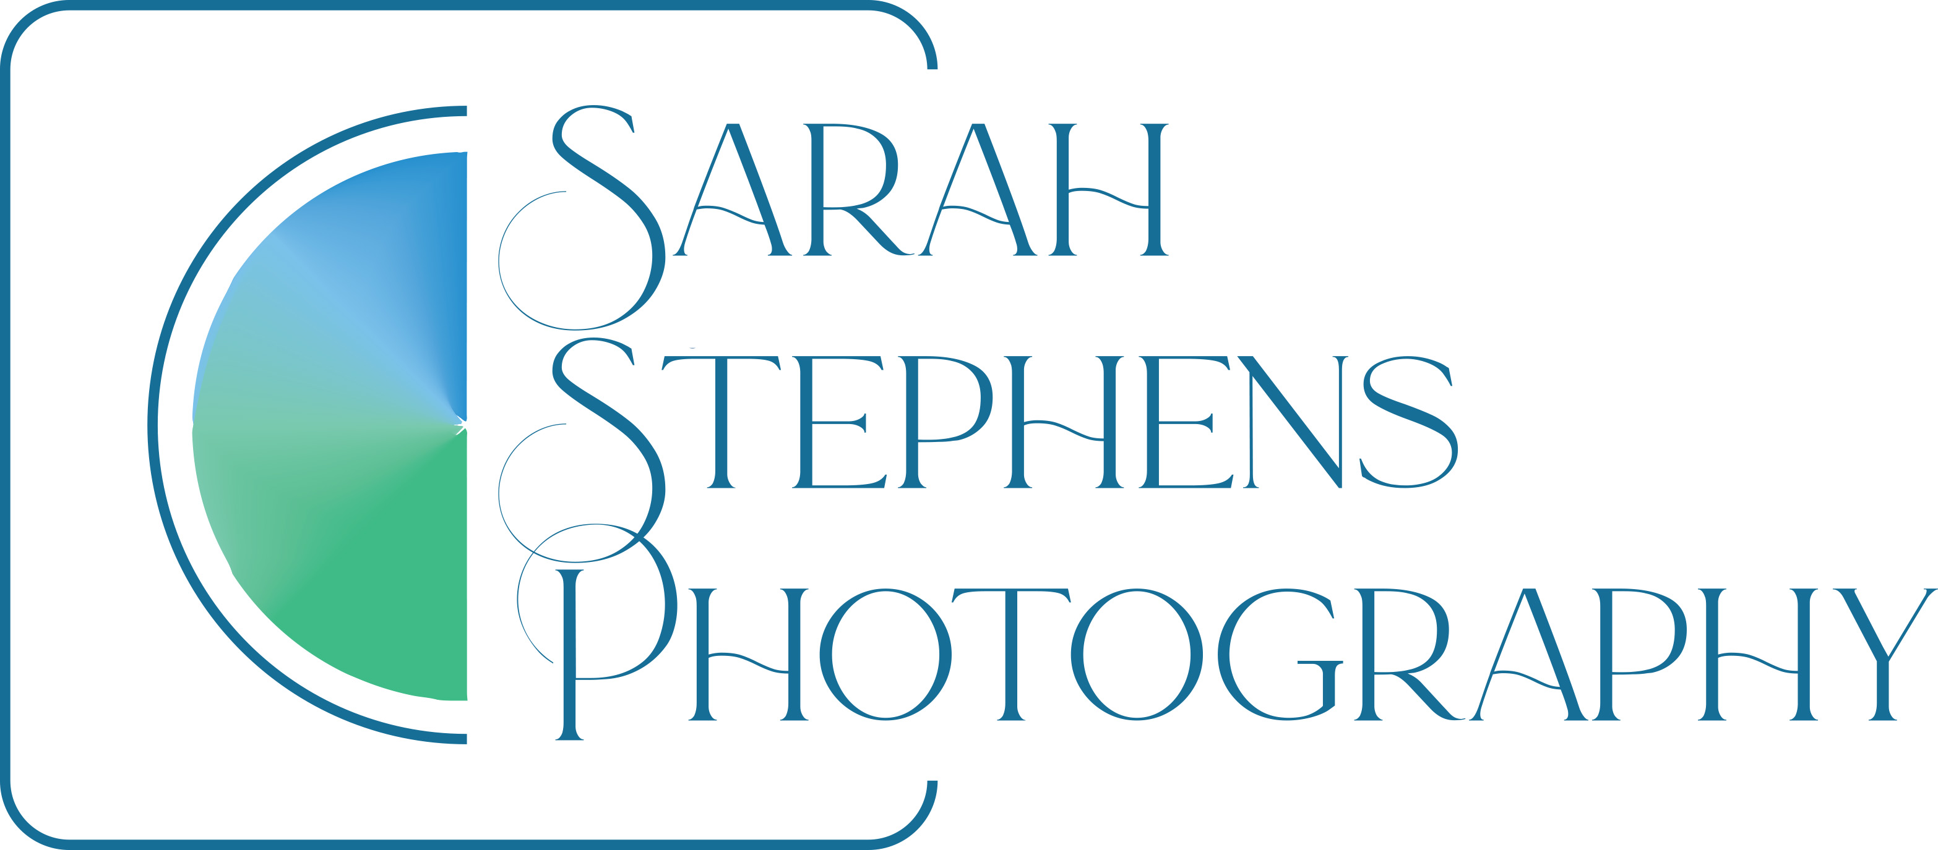

Dear Paul
As requested I have sent copies of my recent images from the Flag Fen event for your archive.
All images have my copyright embedded in the metadata but if used publicly please credit me as Sarah Holmes of Sarah Stephens Photography.
Please state that they are not for reproduction without prior permission.
Thank you for such interest in my images - I look forward to being able to get to another event in the future!

Any queries then please come back to me on sarah@sarahstephens.photography

Best wishes

Sarah

